Chapter 18 written

18.1:

a) A

b) G, H, I, L, M, K

c) 4

d) preorder: A, B, D, G, H, E, I, J, L, M, C, F, K

postorder: G, H, D, I, L, M, J, E, B, K, F, C, A

inorder: G, D, H, B, I, E, L, J, M, A, C, F, K

level-order: A, B, C, D, E, F, G, H, I, J, K, L, M

18.2:

|  |  |  |  |  |  |  |
| --- | --- | --- | --- | --- | --- | --- |
|  | Parent | Children | Siblings | Height | Depth | Size |
| A | - | B, C | - | 4 | 0 | 13 |
| B | A | D, E | C | 3 | 1 | 9 |
| C | A | F | B | 2 | 1 | 3 |
| D | B | G, F | E | 1 | 2 | 3 |
| E | B | I, J | D | 2 | 2 | 5 |
| F | C | K | - | 1 | 2 | 2 |
| G | D | - | H | 0 | 3 | 1 |
| H | D | - | G | 0 | 3 | 1 |
| I | E | - | J | 0 | 3 | 1 |
| J | E | L, M | I | 1 | 3 | 3 |
| K | F | - | - | 0 | 3 | 1 |
| L | J | - | M | 0 | 4 | 1 |
| M | J | - | L | 0 | 4 | 1 |

18.5: 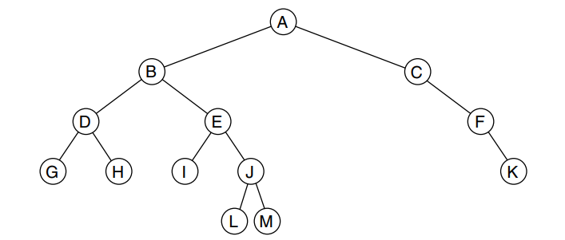2^4+1 – 1 if height is 4 then the max it can have is 31 nodes

2^3+1 – 1 if height is 3 then the max it can have is 15 nodes

2^2+1 – 1 if height is 2 then the max it can have is 7 nodes

2^1+1 – 1 if height is 1 then the max it can have is 3 nodes